EX. NO: 7
IMPLEMENTATION OF RSA
Aim:
To write a C program to implement the RSA encryption algorithm.
ALGORITHM:
STEP-1: Select two co-prime numbers as p and q.
STEP-2: Compute n as the product of p and q.
STEP-3: Compute (p-1)*(q-1) and store it in z.
STEP-4: Select a random prime number e that is less than that of z.
STEP-5: Compute the private key, d as e * mod-1
(z).
STEP-6: The cipher text is computed as messagee
* mod n.

STEP-7: Decryption is done as cipherdmod n.
Program:
#include <stdio.h>
#include <stdlib.h>
#include <math.h>
#include <string.h>
long int p, q, n, t, flag;
long int e[100], d[100], temp[100];
long int j, m[100], en[100], i;
char msg[100];
int prime(long int);
void ce();
long int cd(long int);
void encrypt();
void decrypt();
int main()
{
printf("ENTER FIRST PRIME NUMBER: ");
scanf("%ld", &p);
flag = prime(p);
if (flag == 0)
{
printf("Wrong Input! %ld is not a prime number.\n", p);
return 0;
}
printf("ENTER ANOTHER PRIME NUMBER: ");
scanf("%ld", &q);
flag = prime(q);
if (flag == 0 || p == q)
{
printf("Wrong Input! Enter a different prime number.\n");
return 0;
}
printf("ENTER MESSAGE (lowercase only): ");
scanf("%s", msg);
for (i = 0; msg[i] != '\0'; i++)
m[i] = msg[i];
n = p * q;
t = (p - 1) * (q - 1);
ce();

printf("\nPossible values of e and d:\n");
for (i = 0; i < j - 1; i++)
printf("e = %ld\t d = %ld\n", e[i], d[i]);
encrypt();
decrypt();
return 0;
}
int prime(long int pr)
{
long int i, limit;

if (pr < 2)
return 0;
limit = sqrt(pr);
for (i = 2; i <= limit; i++)
{
if (pr % i == 0)
return 0;
}
return 1;
}
void ce()
{
long int k = 0;
for (i = 2; i < t; i++)
{
if (t % i == 0)
continue;

flag = prime(i);

if (flag == 1 && i != p && i != q)
{
e[k] = i;
flag = cd(e[k]);
if (flag > 0)
{
d[k] = flag;
k++;
}
if (k == 99)
break;
}
}
j = k;
}
long int cd(long int x)
{
long int k = 1;

while (1)
{
k = k + t;
if (k % x == 0)
return (k / x);
}
}

void encrypt()
{
long int pt, ct, key = e[0], k, len;
len = strlen(msg);
i = 0;
while (i < len)
{
pt = m[i];
pt = pt - 96;
k = 1;
for (j = 0; j < key; j++)
{
k = k * pt;
k = k % n;
}
temp[i] = k;
ct = k + 96;
en[i] = ct;
i++;
}
en[i] = -1;
printf("\nEncrypted Message:\n");
for (i = 0; en[i] != -1; i++)
printf("%c", (char)en[i]);
printf("\n");
}

void decrypt()
{
long int pt, ct, key = d[0], k;
i = 0;
while (en[i] != -1)
{
ct = temp[i];
k = 1;
for (j = 0; j < key; j++)
{
k = k * ct;
k = k % n;
}

pt = k + 96;
m[i] = pt;
i++;
}

m[i] = -1;

printf("\nDecrypted Message:\n");

for (i = 0; m[i] != -1; i++)
printf("%c", (char)m[i]);

printf("\n");
}
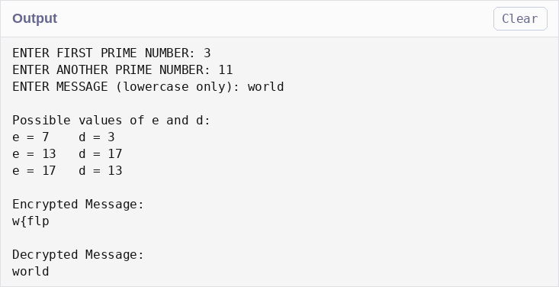
Result:
Thus the C program to implement RSA encryption technique had been implemented
successfully

